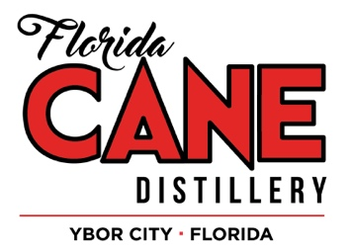
The Florida CANE Distillery | 1820 N. 15th Street | Tampa, FL 33605
(P): 813-302-9696
Sarah.S@FloridaCANE.com
Sarah Jarvis, Brand Marketing Manager

The Florida CANE Distillery is devoted to serving our customers, our employees and our community. When it is possible, we make donations of gift certificates and quality products to the non-profit organizations that help give back to our neighborhood. If your organization is interested in receiving a donation, please fill out this form and send It, as well as your organizations 501(C)3 form to Flora@FloridaCANE.com. Due to the number of requests we receive, this form must be completed 2 weeks prior to scheduled donation pick up.
Date: ________________________________ Tax ID#: ________________________________
Name of organization: ___________________________________________________________

Address: ______________________________________________________________________
Phone number: ________________________ Email: _________________________________
Provide a brief description of your group: ____________________________________________

______________________________________________________________________________

Contact person: ________________________ Date of event: ___________________________
Donation requested: ____________________ Time/Date of donation pick up: _____________

Purpose of donation: ____________________________________________________________
What type of recognition will The Florida CANE Distillery receive for this donation?

______________________________________________________________________________
A copy of your organization’s 501(C)3 must be attached to be considered. Please allow up to 2 business days for an email response. Please email Sarah.S@FloridaCANE.com with any questions regarding donations.

